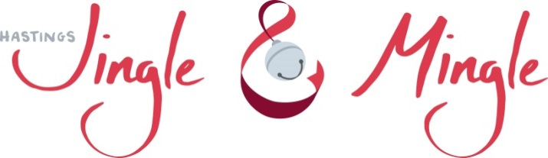

Prince and Princess
Essay contest
“What the Christmas spirit means to me”
Contest out to schools on Oct. 28

Rules:
- Participants must be between the ages of 7-12 years old.
- Minimum length of essay 125 words, but not more than 250.
- Essays must be entirely written by participants.
- Essays must be turned in to Hastings Public Library by November 15, 2019.
- Voting will start on Nov. 18 and end Nov 23, 2019.
- Votes can be cast on line at hastingsjingleandmingle.com or in person at Hastings Public Library, 227 E. State St., Hastings, MI.
- Winners will be notified on November 25, 2019.
- Top two essayists (boy & girl) will be crowned Hastings Jingle & Mingle Prince & Princess at the Mayor’s tree. Other rewards:

- Receive a crown & sash
- Turn on Mayor’s Christmas tree
- Ride in the Rotary Christmas parade
- Be presented to Hastings City Council
- Ride in the St. Patrick’s Day parade
- Receive $25 in Barry Bucks

Name: ___________________________________________
Age: _________ prince ______ princess______
School: _________________________________________________
Phone number: ________________________________________
Parent/Guardian printed: ____________________________________
Parent/Guardian signature: __________________________________

Signature of Parent/Guardian gives permission for Hastings Public Library to publish the essay for public viewing.

Page 1

Prince and Princess
Essay contest
“What the Christmas spirit means to me”
You are welcome to continue on another sheet of paper
Page 2

Prince and Princess
Essay contest
“What the Christmas spirit means to me”
Page 3

