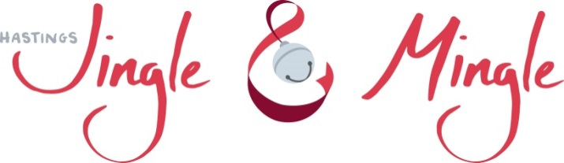

2021 Prince and Princess
Essay contest
“What the Christmas spirit means to me”

Rules:
- Participants must be between the ages of 7-12 years old.
- Minimum length of essay 125 words, but not more than 250.
- Essays must be written entirely by participants.
- Essays are due by November 12 at 6:00 pm. They may be submitted online at Hastings.Jingle.Mingle.2015@gmail.com or at Hastings Public Library, 227 E. State St., Hastings, MI.
- Winners will be determined by a panel of judges and public vote.
- Public voting will start on Nov. 21 and end Nov 27.
- Essays can be viewed and voted for online at hastingsjingleandmingle.com or at Hastings Public Library.
- Winners will be notified on November 29.
- Top two essayists (1 boy & 1 girl) will be crowned Hastings Jingle & Mingle Prince & Princess at the Mayor’s tree. Other rewards:

- Receive a crown & sash
- Turn on Mayor’s Christmas tree
- Ride in the Rotary Christmas parade
- Be presented to Hastings City Council
- Receive $25 in Barry Bucks

Name: ___________________________________________
Age: _________ prince ______ or princess______
School: _________________________________________________
Phone number: ________________________________________
Parent/Guardian printed: ____________________________________
Parent/Guardian signature: __________________________________

Signature of Parent/Guardian gives permission for the Jingle & Mingle committee and the Hastings Public Library to publish the essay and pictures for public viewing.

Page 1

2021 Prince and Princess
Essay contest
“What the Christmas spirit means to me”
You are welcome to continue on another sheet of paper
Page 2

2021 Prince and Princess
Essay contest
“What the Christmas spirit means to me”
Page 3

