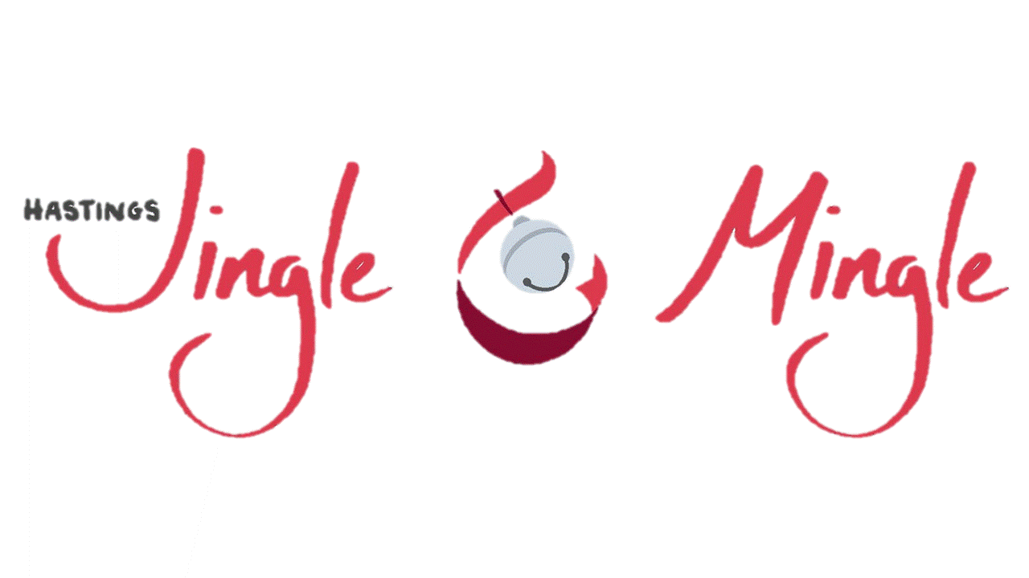

Prince & Princes Essay Contest

Boy #4 (age 11)

What the Christmas Spirit means to me is not a time to get presents but to be happy with what you have, not to ask for more but to thank for what you got, to go sing Christmas carols, to be happy, to see how much you have been given and to be thankful. But other people don’t think that, but I do and I hope you think that we should like what we got and not to be spoiled, but be happy with what you got. To acknowledge what we have because people 100 to 200 years ago did not have what we have, We have planes, technology, medicine but people long ago didn’t have what we have. It was much harder than just going to the store and buying that they had to do it by themselves. So, don’t be a jerk it’s Christmas and that’s what the Christmas Spirit means to me.

