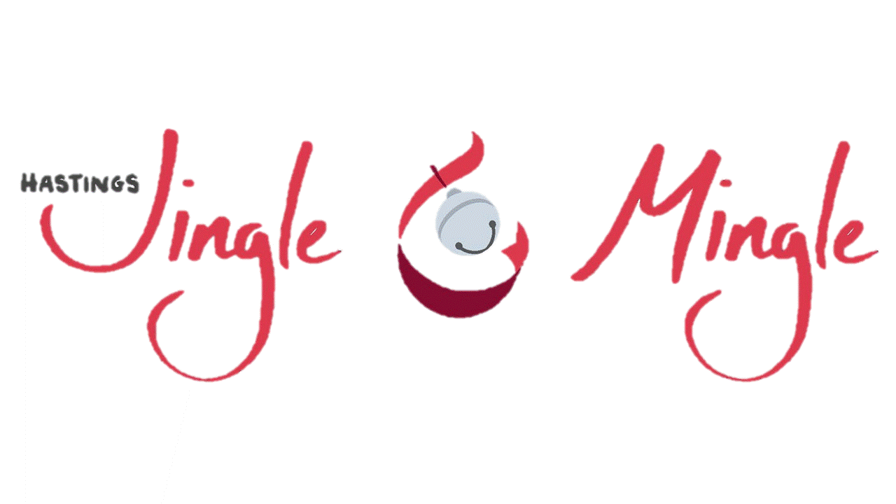

Prince & Princes Essay Contest

Girl #1 (age 8)

What the Christmas Spirit Means to Me
The Christmas spirit means to me that the Son of God Jesus Christ’s birthday is a holy day. It is a holy day because it is the day Jesus Christ was born so Jesus Christ’s birthday is on Christmas. I also think the Christmas spirit isn’t only about getting presents and Santa Claus, it is about giving not getting.
Some of the things we do as a family are M.A.S. M.A.S in our family stands for Many Acts of Service. The silly thing about the word Christmas is that at the end of Christmas it has MAS. What we do is we take 3 jars and we write M on one jar, A on another jar and S on the last jar. We take pompoms and put them in a jar every time we do a service. Our other tradition on Christmas Eve is we tell the Christmas story and watch a movie. Another thing that we do on Christmas Eve is we stay up late. Our siblings give up sleep to spend time with us. Around Christmas time we act out a manger scene while reading Christmas stories. Every year we all sleep in the same room. We always unwrap one present which is matching p-jas. On Christmas we unwrap presents and go to Grandma's house. The most important thing that the Christmas spirit means to me is family, friends and loved ones. That is what matters most.

