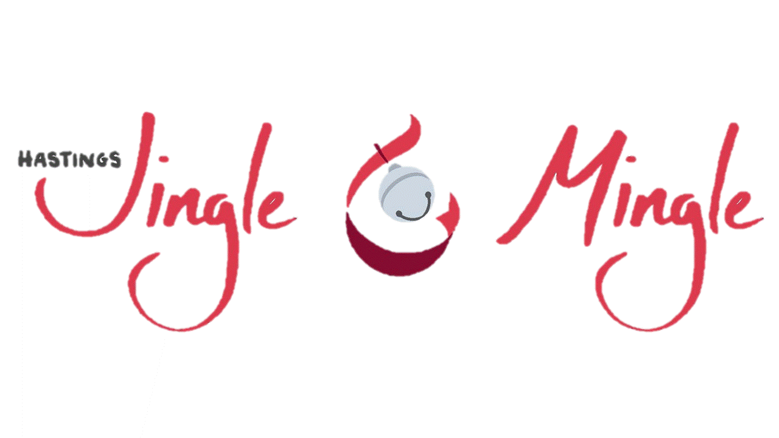

Prince & Princes Essay Contest

Girl #2 (age 11)

What Christmas Means to Me
For most people Christmas is all about family (presents) and joy (and more presents). But in my family Christmas is about playing games and eating jelly beans. On Christmas morning since I was a (very young child I’m still technically a child) child I have to wake up at exactly 5:00 am to go bother my parents to wake up. Then they have to have their coffee before we open anything. Obviously because I am totally super patient I open my stocking while they have coffee. I think the meaning of Christmas to me is getting to go to my great-grandmas house the night before Christmas and get to pass out gifts from under the tree and watch my family play gift passing games while I play with my new gifts. Christmas in my family has a lot of gifts if you can't tell. A few years ago my family played a game where you have to unwrap a present from bubble wrap before the other person can roll a double with dice, since my great aunt really likes parties and games she bought like 100 feet of it! Most of the games played in my family are about presents (and sometimes lottery tickets), but I think Christmas to me is about family (and spicy gummy bears).

